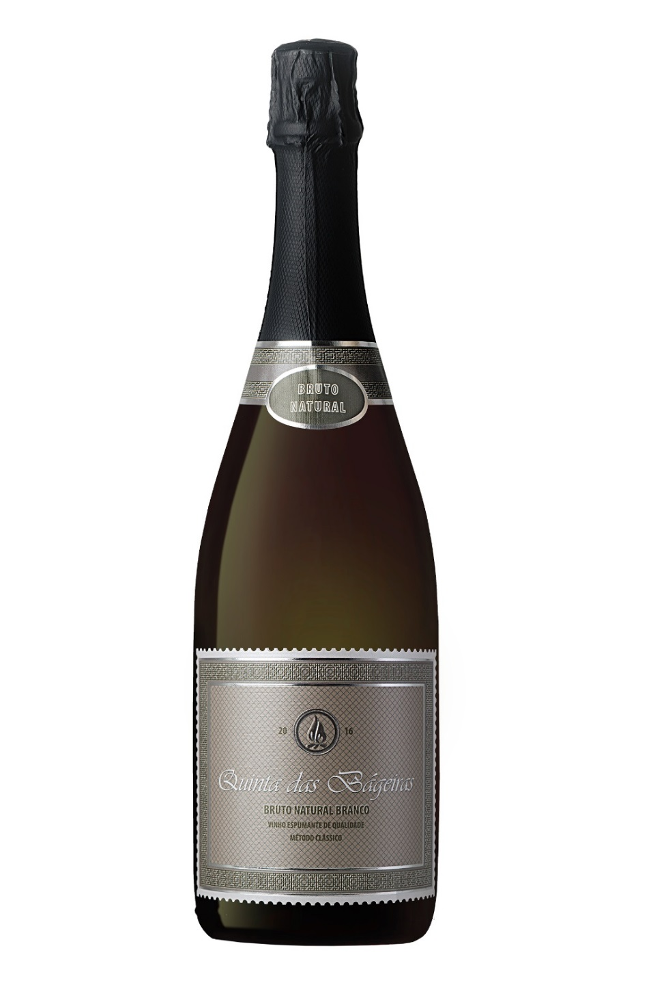
MARCA: QUINTA DAS BÁGEIRAS
Região: Bairrada
Produto: Espumante Bruto Natural
Ano: 2016
Castas: Maria-Gomes e Bical
Álcool: 12,5%vol.
Acidez total: 6,8
It is vinified through fermentation of skins, where the must is placed in small decanters of 1 m3, remaining there for 24 to 36 hours to be decanted through natural precipitation. At the end of this process, the must is transferred to stainless steel barrels were it ferments, with temperature control achieved through cooled water. There's special care involved in picking the grapes with the right balance between acidity and alcohol. The base wine goes through a sparkling process, usually in March of the following year and, in the case of Reserva, it is aged for 12 months in the cellar before the dégorgement. It is a sparkling wine produced through traditional methods, fermented in the bottle, and the remuage is done by hand in wooden pupitres. Since it is a bruto natural, it has no added sugar in the liqueur d'expedition

